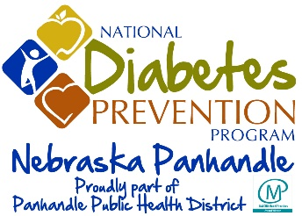

Patient Authorization to Disclose Health Information

Pre-Participation Authorization to Use and Disclose Medical Information

Applicant's Name (printed):
Date of Birth:
Address:
I intend to participate in the National Diabetes Prevention Program. I hereby authorize and request Regional West Medical Center to disclose some of my medical information to Panhandle Public Health District ("PPHD"), the organization that administers the National Diabetes Prevention Program. I understand the information to be disclosed includes the following medical information:

___ Weight and physical activity minutes
___ Prediabetic qualifications
___ Participant Personal Information Document
___ Blood Pressure Readings

I understand that I have the right to inspect the medical information that is being disclosed at any time. I also understand that the disclosing provider may not condition further treatment on my signing this Authorization.

I understand that the health information disclosed to PPHD per this Authorization may be subject to re-disclosure by PPHD.

I understand that I have the right to revoke this Authorization at any time, except to the extent that action has been taken in reliance on it. Revocations must be sent to: Lifestyle Coach Name, Organization, Address. A copy of this Authorization shall be as valid as the original.

This authorization will expire after I have completed participation in the National Diabetes Prevention Program.

Date Signature: Applicant (Indicate if unable to sign)

Date Signature: Designated Representative Relationship

